**Sales Performance Analysis**

**Objective**

In order to help Mike Goodman to build a dashboard that will present monthly sales performance by product segment and product category to help client identifying the segments and categories that have met or exceeded their sales targets, as well as those that have not met their sales targets.

**Our Findings**

Except October and April, Consumer Segment is performing very well as compared with Sales Target across all categories.

* Except February, Cooperate Segment is performing very well as compared with Sales Target across all categories.

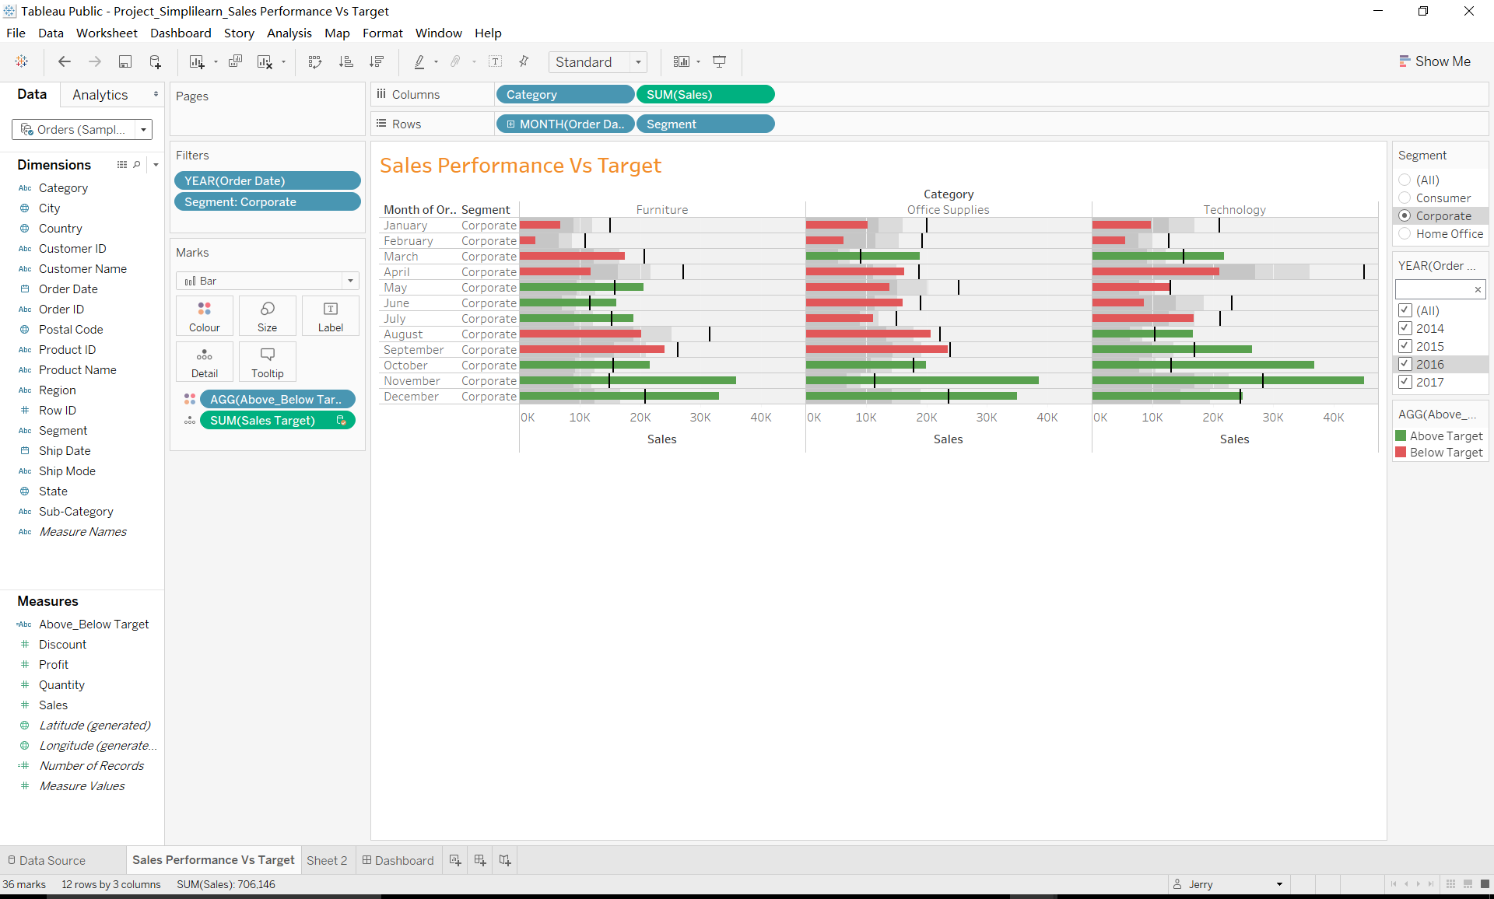

* Home Office Segment is generating Low Sales in Furniture and Office Supplie category except Technology.

-> In February and July from Home Office Segment, Technology is generating Sales under target.

-> From January to August, Home Office Segment is Generating Low sales among all Segment and it is also Under Budget in Some Categories.

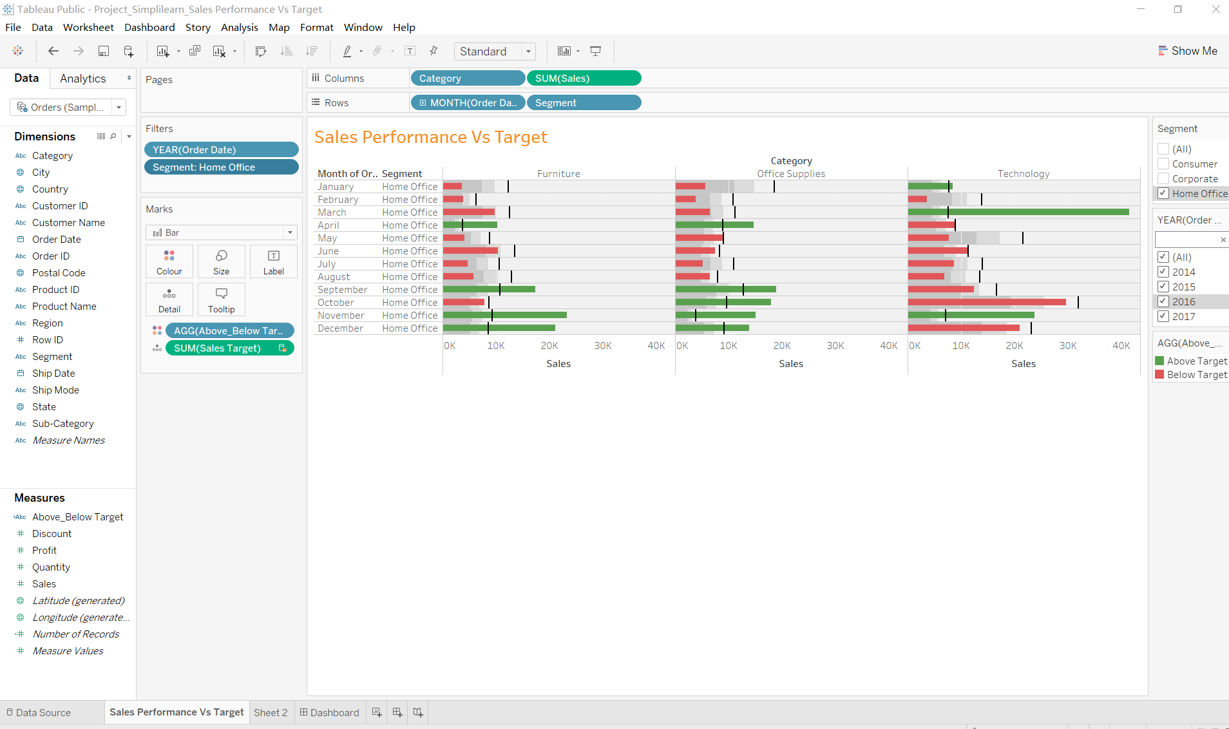

* In 2017 there is a huge trend of Under Budget, Except January Office Supply, all others are Under Budget.

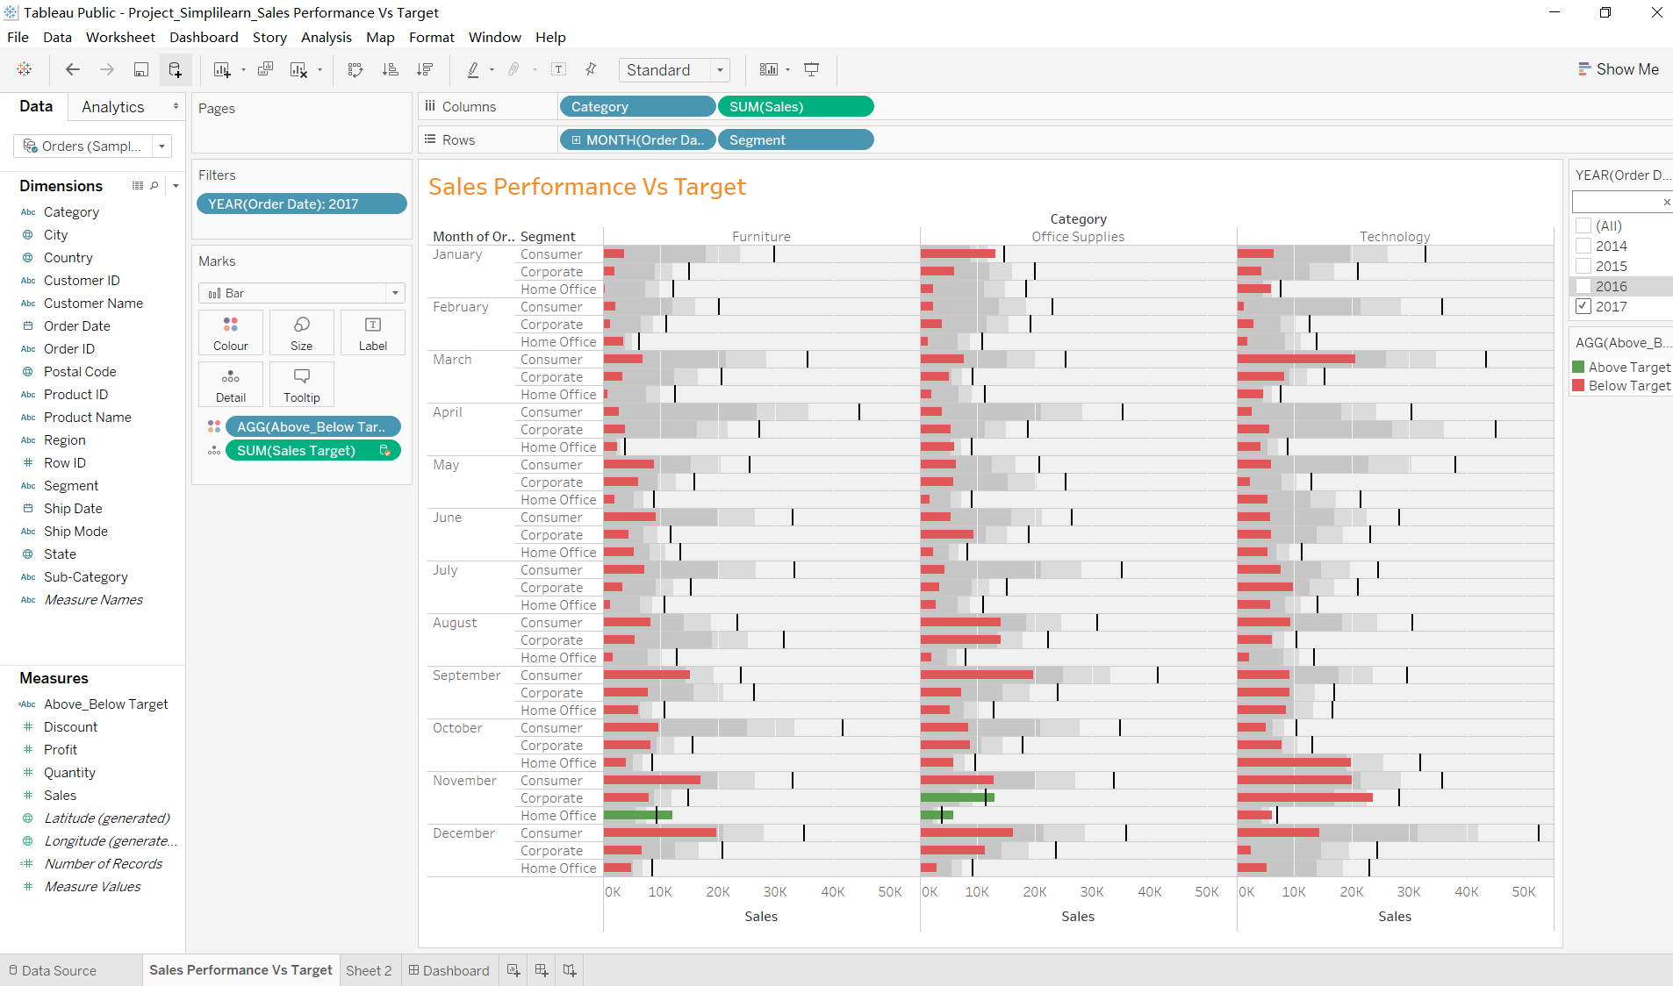

**Tableau Public Link**

https://public.tableau.com/views/Project_Simplilearn_SalesPerformanceVsTarget_15839064719310/SalesPerformanceVsTarget?:display_count=y&publish=yes&:origin=viz_share_link